
Department | FED
Subject | DSA-2
Academic Year | Ⅰ-Ⅲ Semester(2025-26)
Faculty Name | Ms. Alluri Swathi
Student Name | Keerthi Priya Ande
Roll Number | 2520090177
Branch | CSIT
Course Outcome | 1
Case Study Topic: CampusFlow – University Campus Resource Management System

Work Done Summary:
Implemented a Binary Search Tree (BST) in Java keyed by roomId / bookingId / scheduleId. Inserted multiple classroom, laboratory, faculty allocation, and student booking records into the BST. Implemented classroom scheduling, faculty allocation, laboratory booking, student service request handling, campus resource management, and infrastructure analytics operations. Deleted invalid or duplicate booking records and maintained proper BST structure. Implemented traversal methods for displaying campus schedules and resource allocations in sorted order. Added methods for searching classroom availability quickly and generating campus utilization statistics. Compared BST performance with ArrayList – BST provides faster searching and organized data handling for university campus management systems.

Implementation Details :
1. Created BST Node class with fields: key, roomId, facilityName, bookingDetails, left, right.
2. Insert() recursively inserts new classroom, laboratory, and booking records into the BST.
3. Search() finds classroom availability, faculty schedules, and student booking details.
4. Delete() removes cancelled or duplicate booking records.
5. InorderTraversal() displays classrooms, schedules, and bookings in sorted order.
6. ResourceAllocation() manages classroom and laboratory allocation efficiently.
7. UtilizationAnalytics() calculates campus resource usage statistics.
8. The main method demonstrated classroom booking, faculty allocation, searching, deletion, analytics, and campus schedule reporting.

Result : Screenshots/Output:

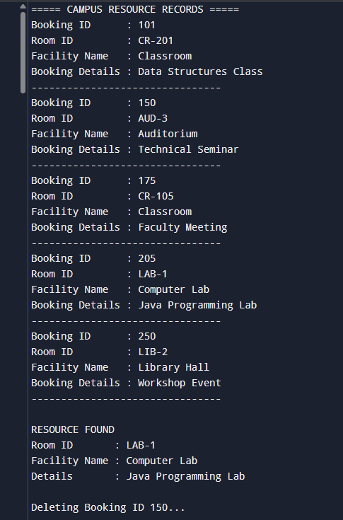

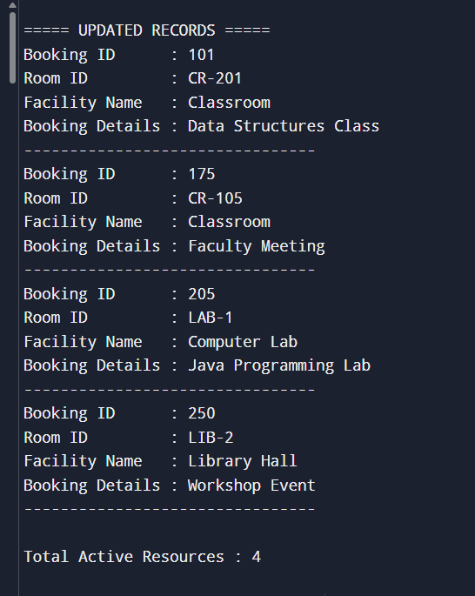

Time Complexity:
- BST Insert/Delete/Search: O(log n) (average case)
- Resource Allocation Traversal: O(n)
- Compared to ArrayList searching O(n), BST performs better for large-scale campus resource management.

GitHub Link :
Student Signature | Faculty Signature

